AGENTS AND DISTRIBUTORS NUMBER

In previous topic, we have already examined how demand varies with change in [commission of agents and distributors](http://gmcworld.org/blog/agents-and-distributors-commission). In this topic, we will analyze the dependence of demand on change in number of agents and distributors.

**Test - Scenario 12C1 - Product 1 (EU)**

Effect on demand from number of agents change comes only in next period. There were only few clean tests for representative sample, so chart is based on the most similar reports for EU market. Dependence is power function, decreasing. Almost no influence on demand from competitors in the group, control points lie quite close to the trend line. For Nafta market, dependence of demand on number of agents change is almost identical with data for EU market. Given that the commission of agents and distributors equally affects on demand in EU and Nafta markets, it can be concluded that number of agents and distributors also has the same impact on demand in EU and Nafta markets too. In fact, the only difference between EU and Nafta is the name - “agents” in the EU market and “distributors” in Nafta market, otherwise impact is equal.

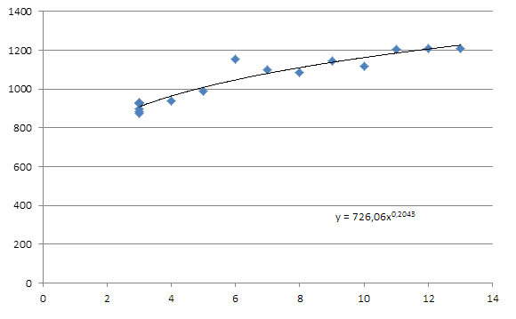

*In previous version of GMC simulator, effect on demand from change in number of agents and distributors from competitors in the group was significantly higher. The more was the difference in number of agents and distributors between your company and opponents, the greater demand increase you received. For several seasons it was favorite strategy of Asian teams - Swing: in 1 period teams were hiring up to 20 agents in EU market, which then were dismissed in 2 period. Costs increasing for hiring agents and distributors was offset by great increase in demand in 2 and next periods. In new version of GMC simulator, due to changes in calculation of payments to agents (maximum commission and support for previous and current period is used in calculation), possible bonus from swing strategy has come to naught.*

"Swing" strategy was specially tested in new version of GMC simulator in 2 control groups on 12C1 scenario. Agents and distributors were hired in 1 period, followed by comparison of demand increase between groups:

1．With increasing number of agents in EU market from 3 to 14, demand growth in both groups was 43.1%

2．With increasing number of agents in Nafta market from 4 to 9, demand growth in both groups was 17.6%

Since demand growth was the same in both control groups, despite different number of agents and distributors from competitors in each group, it can be assumed that influence of competitors on demand is absent when there is a change in number of agents and distributors:

**Hints**

1．Dependence is power function

2．Effect is equal for EU and Nafta markets

3．Effect is equal for all products

4．Cumulative effect is very small

代理商和经销商数量

在上一个主题中，我们已经研究了需求随代理商和分销商佣金变化而变化的情况。 在这个主题中，我们将分析需求对代理商和分销商数量变化的依赖。

**测试 - 情景12C1 - 产品1（国内）**

对代理人数量变化的需求影响仅在下一个时期。 对于代表性样本，只有少数干净的测试，所以图表是基于国内市场最相似的报告。取决于幂指数函数，递减。控制点几乎不受竞争对手的需求影响，控制点非常接近趋势线。对于北美市场，需求对代理商数量的依赖性几乎与国内市场的数据相同。鉴于代理商和分销商的佣金同样受到国内和北美市场需求的影响，可以得出结论，代理商和分销商的数量也对国内和北美市场的需求产生了相同的影响。事实上，国内和北美之间的唯一区别是国内市场上叫“代理商”和北美市场上叫“经销商”，否则影响是平等的。



在以前版本的GMC模拟器中，来自竞争对手的代理商和分销商数量变化对需求的影响显着增加。 您的公司和对手的代理商和分销商数量之间的差异越大，您收到的需求就越大。几个赛季，这是亚洲队最喜欢的策略 – Swing：在第一期队伍中，雇佣了20名国内的代理人，然后在第2期被解雇。 招聘代理商和分销商的成本增加被二期和下一期的需求大幅增长所抵消。 在新版本的GMC模拟器中，由于代理人付款计算的变化（最近佣金和以前和当前期间的支持用于计算），Swing策略的可能奖金已经没有了。

“Swing”策略在12C1情景下的两个控制组的新版本的GMC模拟器中进行了特别测试。 代理人和经销商在1个工作日内被雇用，其次是组间需求增长的比较：

1．国内市场上的代理商数量从3个增加到14个，两类需求增长了43.1％

2．北美市场的代理人数量从4家增加到9家，两组的需求增长率分别为17.6％

由于两个控制组的需求增长相同，尽管各组竞争对手的代理商和分销商数量不同，但假设当代理商和分销商数量发生变化时，竞争对手对需求的影响是不存在的：

**提示**

1．依赖于幂指数函数

2．国内和北美市场的影响是相当的

3．对所有产品的影响效果是相同的

4．累积效应非常小